**University of engineering & technology Peshawar**



**COMPUTER PROGRAMMING -LAB**

**Lab report # 4**

**Fall 2020**

**Submitted by: Ashfaq Ahmad**

**Section: B**

**Reg No: 19PWCSE1795**

**Semester: 2nd**

**Submitted to:**

**Eng: Abdullah**

**Department Of Computer System Engineering**

## Objectives:

## To understand the programming knowledge using Decision Statement “switch”

* To understand the programming using for Loop
* **Task 1:**

Write a program to create Simple Calculator using switch case.

**Source code:**

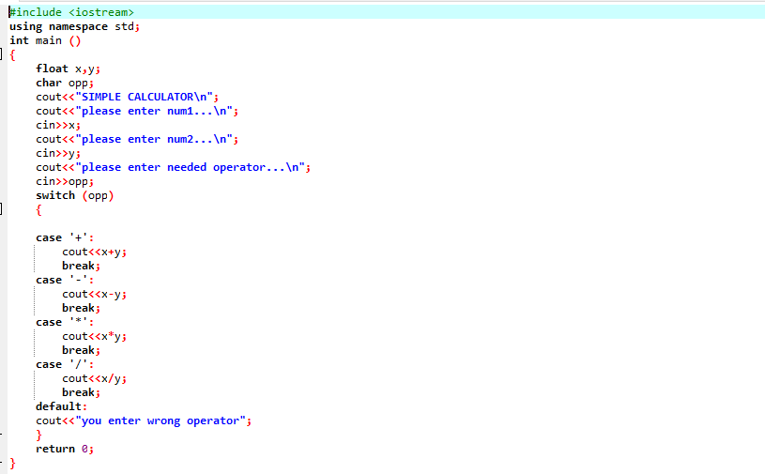

**Compilation:**

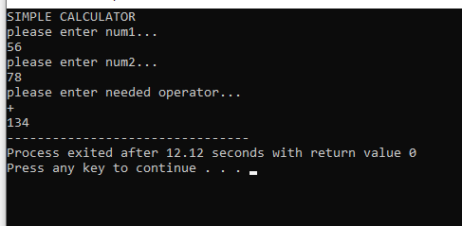

* **Task 2:** Write a program to find Factorial of a number.

**Source code:**

: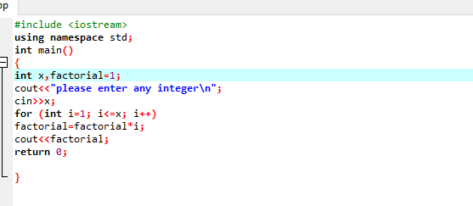

**Compilation:**

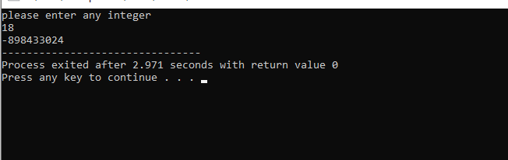

* **Task 3:**

Write a program to print multiplication table of any number.

**Source code:**

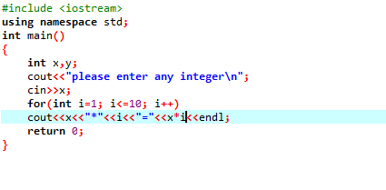

**Compilation:**

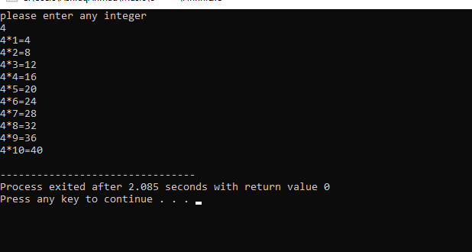

* **Task 4:**

Write a program to check if a number input by user is PRIME or not, range of input is 1 to 300.

Source code:

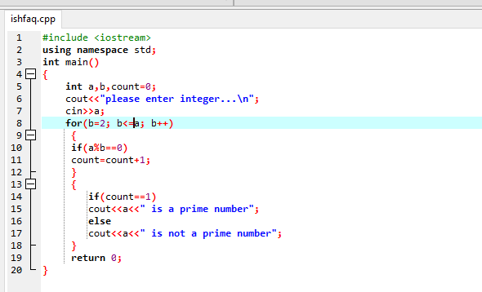

**Compilation:**

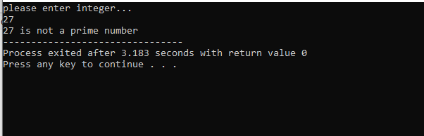

* **Task 5:**

Write a program that takes the base and exponent as input and display the result of power.

**Source code:**

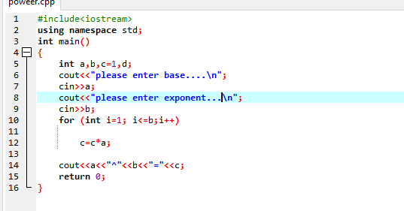

**Compilation:**

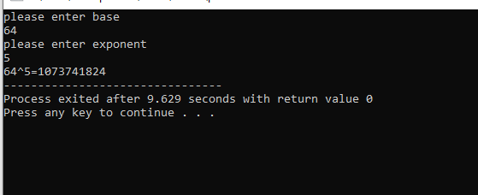

* **Task 6:**

Write a program to display Fibonacci series up to 200.

Fibonacci series: 0, 1, 1, 2, 3, 5, 8, 13…

**Source code:**

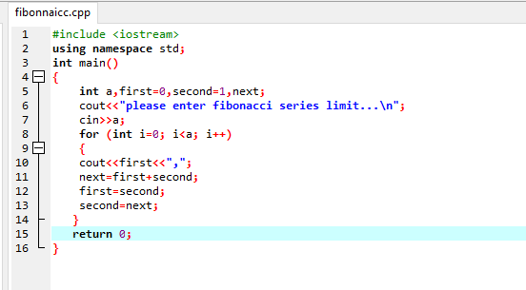

**Compilation:**

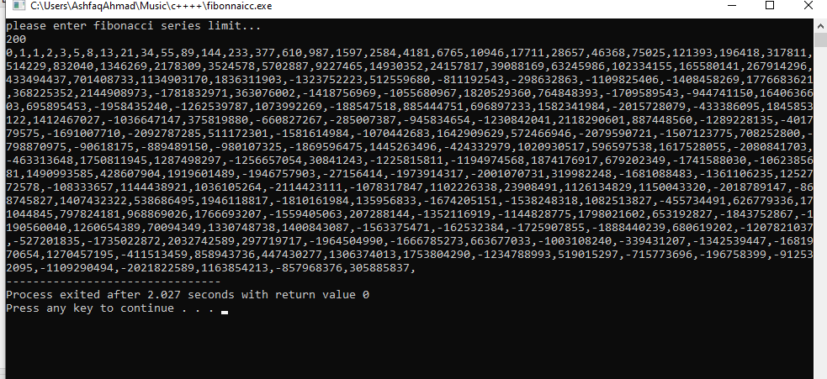

* **Task: 7**

Write a program to find GCD (greatest common divisor or HCF) and LCM (least common multiple) of two numbers.

**Source code:**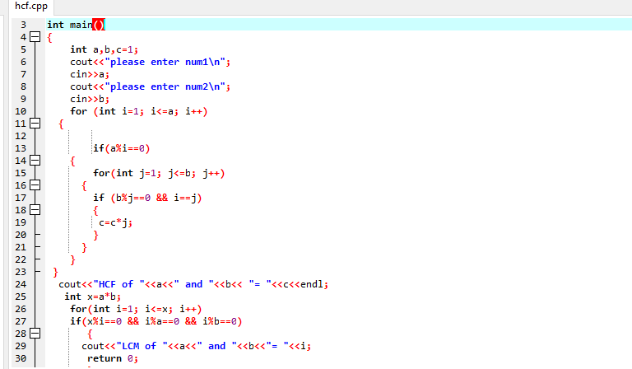

**Compilation:**

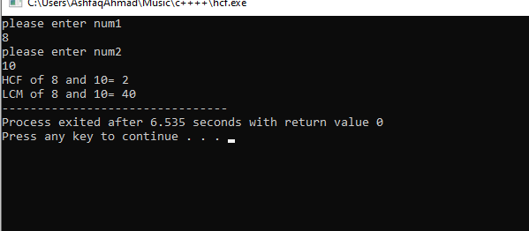

* **Task 8:**

Write a program to input two integer numbers and display the sum of even numbers between these two input numbers.

**Source code:**

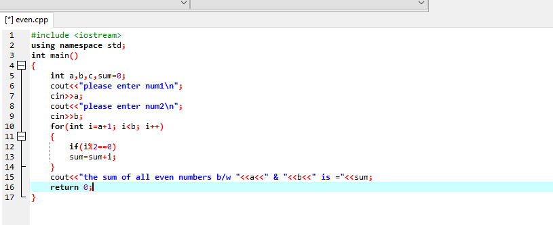

**Compilation:**

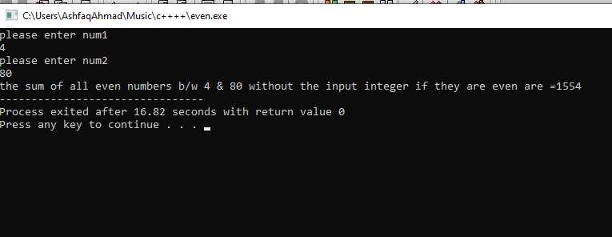

* **Task no 9:**

Write a program to print all natural numbers in reverse (from n to 1).

**Source code:**

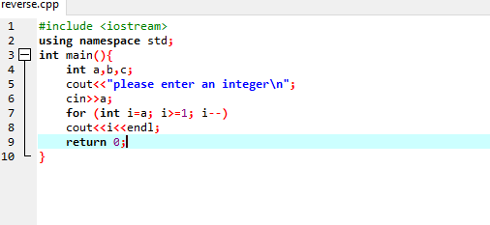

**Compilation:**

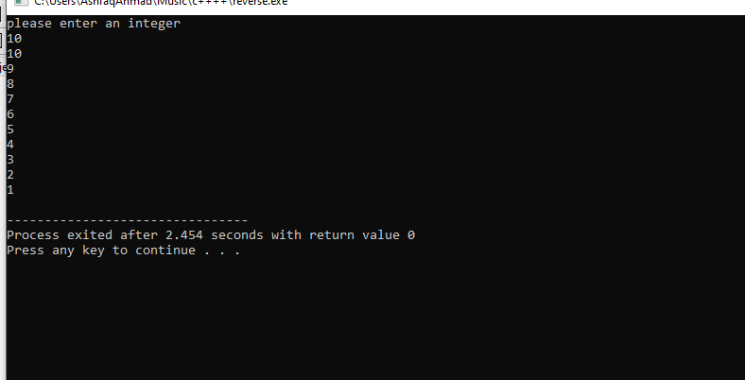

* **Task no 10:**

Write a program that takes a number as input, checks it if it is between 1 and 10 (using switch) and if it is invalid range your program should output a line containing that number of adjacent asterisks. On invalid input number, the program should end.

**Source code:**

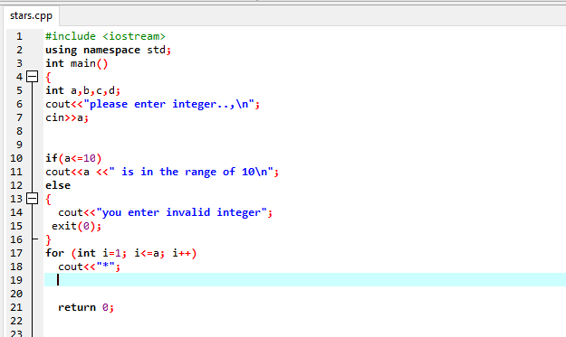

**Compilation:**

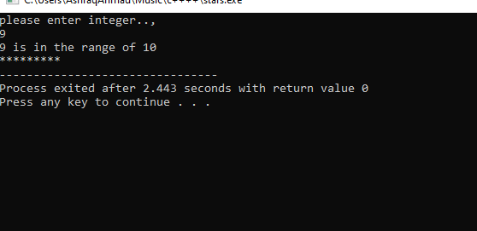

* **Task no 11:**

Write a program that performs a survey tally on beverages. The program should prompt for the next person until a sentinel value of –1 is entered to terminate the program. Each person participating in the survey should choose their favorite beverage from the following list:

1. Coffee 2. Tea 3. Coke 4. Orange Juice

**Source code:**